**Assignment -1**

Smart Solution for Railways

|  |  |
| --- | --- |
| Assignment Date | 25 September 2022 |
| Student Name | K.Manikandan |
| Student Roll Number | 721219106025 |
| Maximum Marks | 2 Marks |

**Circuit:**

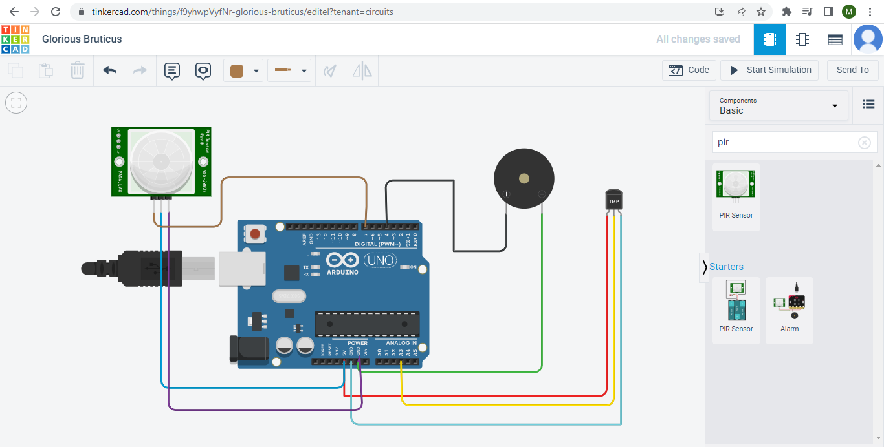

**Code:**

void setup()

{

Serial.begin(9600);

pinMode(4,OUTPUT);

pinMode(7,INPUT);

}

void loop()

{

intmov=digitalRead(7);

doubledt=analogRead(A3);

double n=dt/1024;

double volt=n*5;

double offset=volt-0.5;

double temp=offset*100;

Serial.print("Temperature Detected: ");

Serial.println(temp);

if(mov==0){

Serial.println("No Motion Detected");

}

if(mov==1){

Serial.println("Motion Detected");

tone(4,100,1000);

}

if(temp>60){

tone(4,400,1000);

}

}

**Output:**

